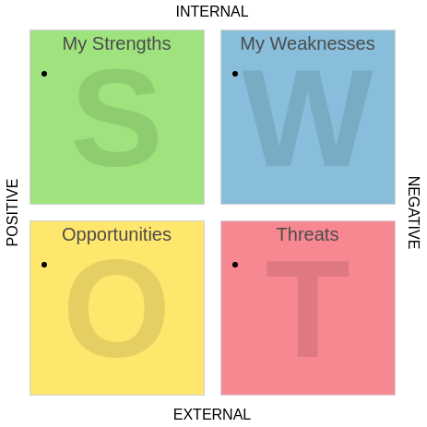

Write your strengths and your weaknesses the opportunities that you face and the threats to you setting up and succeeding your business.
When you finished it, sit back and have a good look at it.
- Consider how your strengths are going to help you in setting up, developing and running your business.
- Take a hard look to your weaknesses .Are really weaknesses? It is a lack of knowledge?
- Look at the opportunities and think how you can make the most of them. For example if you are thinking baking and selling cakes then what opportunities might there be to get you started? Selling at the school festivals, baking for birthday parties?
- Have a very careful look and define which of these threats are real or is your fears? Real threats could be money and lack of any support.
Source:women;s business book

